Number of pages read.

Number of tests.

Problrm solving time.

Mistakes done.

Help request

Timing parameters( avg hints req,% of all helped probs)

Current task and expected time.

Difficulty of content.

Group eng n similarity of participation - criteria



 {\displaystyle H=-\sum _{i}p_{i}\log _{b}p_{i}}The Gini coefficient measures the inequality among values of a [frequency distribution](https://en.wikipedia.org/wiki/Frequency_distribution)

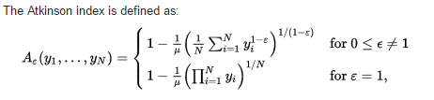

The Atkinson € {\displaystyle \varepsilon }€parameter is often called the "inequality aversion parameter”

 {\displaystyle y_{i}}y y is individual income